**Lesson Notes**

1. What is the main purpose of an Operating System?

Simpler/more efficient application programs

Consistent user experience

Allow multiple applications running at same time

1. What is the difference between Operating System Software and Use Application Software?

Hardware independence

User interface

Resource allocation

1. What is the difference between Operating System Software and Computer Hardware?

Hardware is touchable, OS is intangible. Software controls all PC operations.

1. What are the main parts of an Operating System?

Graphical user interface

Systems calls

Device drivers

I/O Manager

1. What are some popular operating systems?

Windows

iOS

Android

**Reference Diagram**

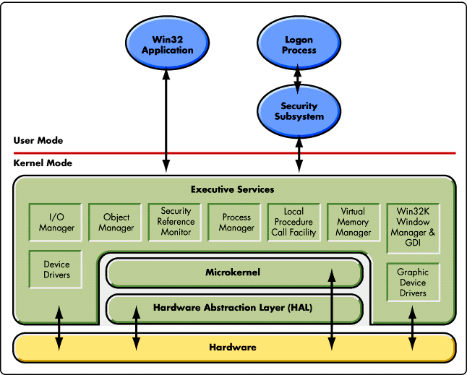

**Student Questions**

1. What is a device driver?
   1. Provide a brief summary

Helps the device run properly in conjunction with the software

* 1. List some devices that require a device driver.

GPU, Sound card, Printer

* 1. Provide a label on the reference diagram for the location of a device driver for your graphics card.
  2. Provide a label on the reference diagram for the location of a device driver for a locally attached printer.

1. What is a DLL?
   1. Provide a brief summary

When a program is ran on Windows OS, much of the functionality of the program is provided by a DLL

* 1. Explain how DLLs are related to user application programs

Helps functionality of program

* 1. Provide a label on the reference diagram for the location of a DLL

1. What is a windows manager?
   1. Provide a brief summary

Coordinating all windows on screen

* 1. Explain how a windows manager is related to user application programs

Every program running is controlled

* 1. Provide a label on the reference diagram for the location of a DLL

1. What is the windows task manager?
   1. Provide a brief summary

Shows a list of all background and foreground operations running. You can force end tasks.

* 1. List and explain four (4) types of system information provided by the task manager

Programs running, resource use, users signed in on computer, what tasks are doing.

* 1. Provide a label on the reference diagram for the operating system components related to each type of information.